The “3 Box” model of digital engagement

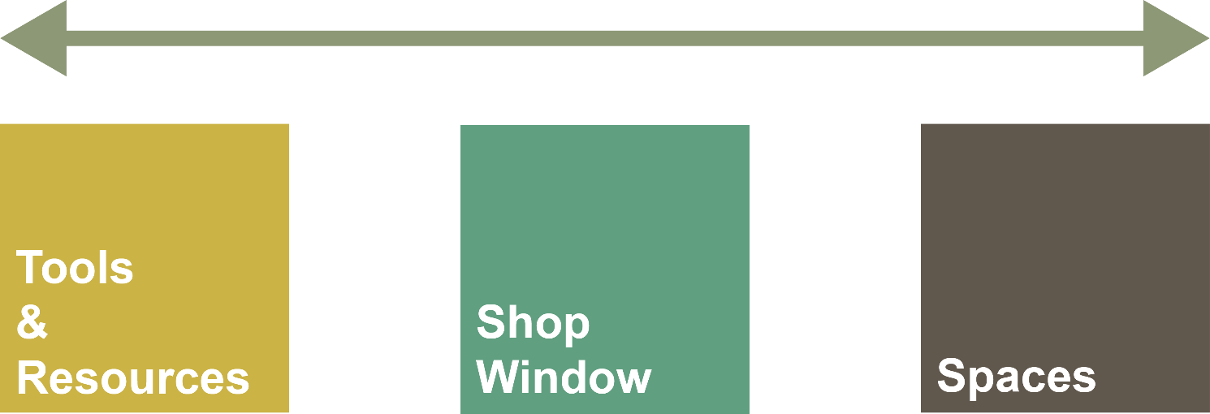

A simple model for mapping the role and value
of the digital in teaching creative disciplines

David White
Head of Technology Enhanced Learning
Teaching & Learning Exchange
University of the Arts London

The use of digital technology as a source of information and/or a collection of tools for completing specific tasks

Much of what is commonly described as eLearning is situated within this category, even though for the most part it is used simply to broadcast information to students. Here, technology is seen as a means to provide access to and distribute content. Activities in this category leave behind no social traces.
Capabilities required to engage within this category
The ability to access technology and to get online - searching and browsing skills - a range of critical thinking/evaluation abilities – skills in specific software, e.g. the use of Photoshop. This is the category in which students have a high level of expectation for institutional provision, and in which they most commonly operate as they move through their programmes of study.
Examples of activity in this category
- Looking up information on Wikipedia
- Finding an appropriate eJournal from the library
- Reviewing a PowerPoint on Moodle
- Discovering images on Flickr
- Submitting an assignment via Moodle
- Using Photoshop, Word, Excel or any other software
- ‘Elegant lurking’ in forums or Social Media (‘watching’ discourse)


The use of the Web to present work
This category is particularly relevant for students working in creative disciplines where their persona and creative outputs are highly intertwined. The notion of ‘audience’ in an online context becomes relevant. Activity in this category presents an individual’s persona via their work and so leaves a trace via artefacts online.

Presenting work online is now a key factor in becoming established in a given field, but is an area which students often find daunting. Activity in this category is also usually undertaken in a ‘broadcast’ mode. This is about presenting work but not necessarily reflecting on it or engaging in discussion around it online. Students’ ‘work’ is likely to be created offline and then posted to the Web when it’s completed.

Capabilities required to engage within this category
The ability to convert work into digital formats. The ability to curate work and present it online in a format which resonates with relevant audiences. This category also requires the individual to have a sense of themselves as a practitioner and the confidence to begin to express their practitioner-identity via their work.

Examples of activity in this category
- Posting work to Flickr
- Creating a basic LinkedIn profile
- Creating an ‘open’ ePortfolio site
- Setting up a basic personal website


The Web as a series of spaces/places in which we can be co-present with others, enacting practice and engaging in discourse

Activity in this category is predicated on the socially connected nature of much of the Web. The Web is transformed into a location where thinking and making can be developed in tandem in a networked or communal manner. In this category individuals are motivated to go online to be present with others in some form. This could be in a highly open manner (reached by anyone via a Google search for example) or within known groups or communities. Operating in this category requires some form of digital identity and leaves behind social traces online.
Activity in this category can be divided into a number of areas
- Discourse around objects: This could be as simple as discussing an assignment brief or a creative artefact in a Facebook group.
- Evolving work: Making the process of producing work visible online and seeking comment/discussion towards developing the work. This can be described as ‘open practice’.
- Critique or re-appropriation of the digital: Approaching the digital as a socio-cultural/visual location to be interpreted through the lens of creative practice.

Capabilities required to engage within this category
The ability to express opinions and engage in discourse via a digital identity. The ability to collaborate and the confidence to discuss/present the evolution of ideas and work. In this category individuals have to develop their ‘voice’ or sense of self and be capable of expressing themselves in a variety of modes. Individuals also need to feel a sense belonging to one or more online network/community. Successful activity in this category usually requires individuals to be ‘agile’ in their appropriation of digital technology in the service of their own aims/creative vision.
Examples of activity in this category
- Blogging with an expectation of a response/dialogue
- Engaging in dialogue on Twitter
- Collaborating on a group project in Workflow
- Commenting on and discussing images in Flickr
- Being an active member of a Facebook group
- Being an active member of an email list
- Collaboratively evolving work via a cluster of technologies (Skype, Facebook, Dropbox etc)
- Posting a series of videos documenting the evolution of a project and responding to comments

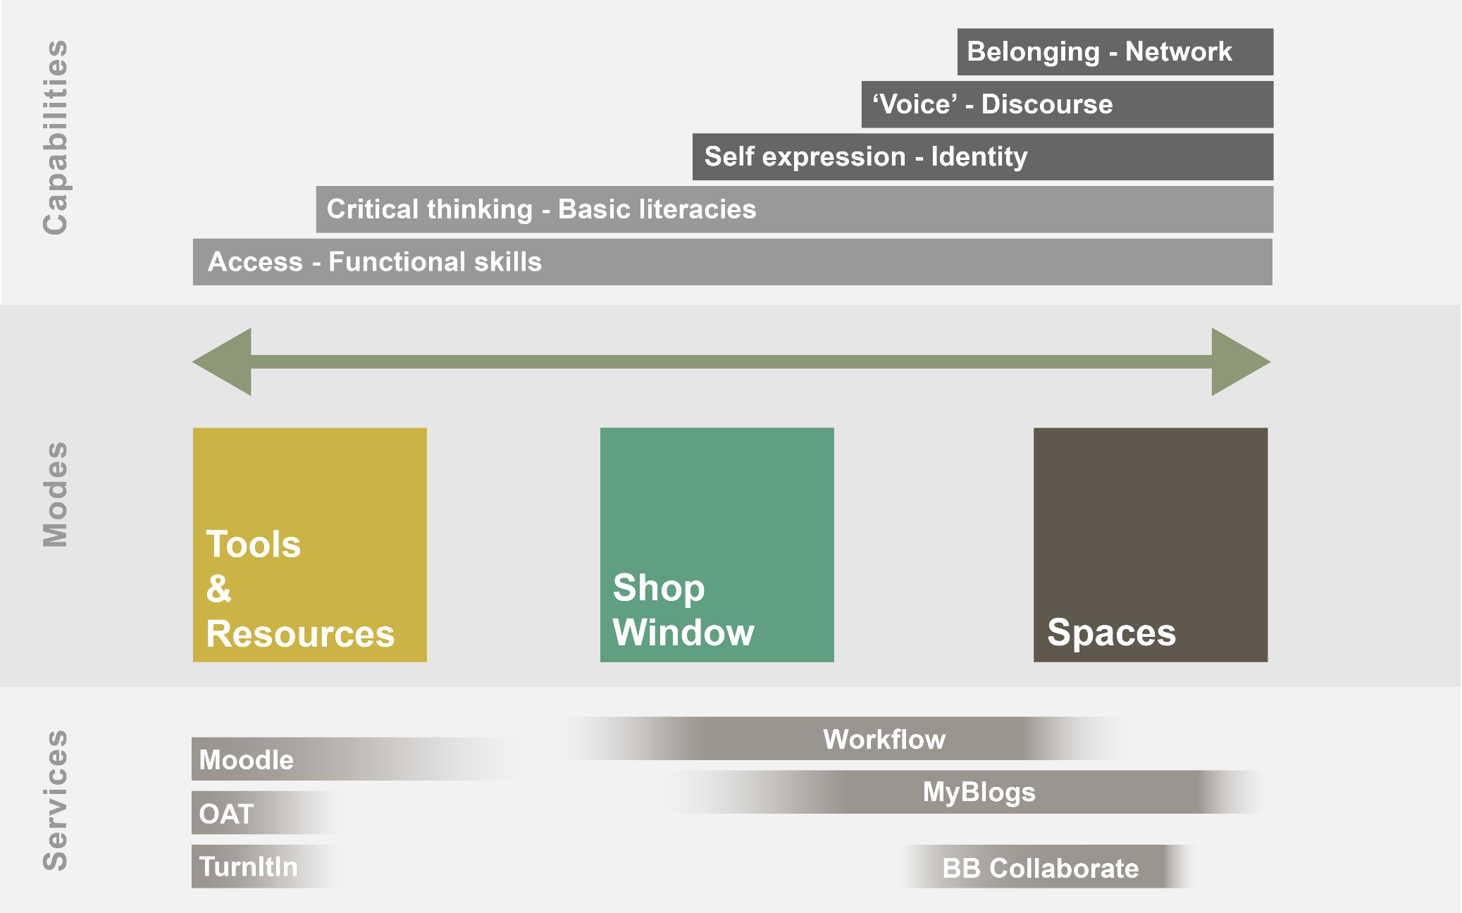 | Technology enhanced Learning services at UAL

